|  |  |  |
| --- | --- | --- |
| E-mail : RHPL2002@yahoo.in | **HEALTH IS WEALTH** | M. 8734003005 Ph. 0278-2423876 |
| **M A L A V I A E Y E H O S P I T A L**  (Unit Radheshyam Hospital LLP) | | |
| Dr. C. D. MALAVIA  M.B;D.O.M.S;M.S.(Ophth.)  Eye Surgeon Reg. No. G-6712  Phaco and Laser Specialist | C:\Users\DWIJA\Desktop\Income Tax FY-2020-21\hi\Logo.png | Plot No: 1, Marine Society,  Opp. Adarsh Complex,  Jail Road, Bhavnagar- 364001.  Time: 10 to 1, 5 to 7-30 |

Date: 20-Sep-2023

**CERTIFICATE**

This is to certify that Shri/Smt. **MANOJKUMAR JOSHI** is / was suffering from LE CATARACT and operated for LE MICS on 20/09/2023.

He / She is under my treatment as an Outdoor / Indoor Patient Since Date: 20-Sep-2023 to Date: 20-Sep-2023. He / She is advised to rest from Date: 20-Sep-2023 to Date: 10-Oct-2023. He / She is fit for his/her duty from Date: 11-Oct-2023.

It was necessary to implant intra Ocular Lens to get better vision in Left and Right eyes after Cataract Operation.

This hospital has 10 (ten) bed capacity with full equipped diagnostic set-up and operation theatre.

This hospital has applied for registration with Local Authority. (B.M.C)

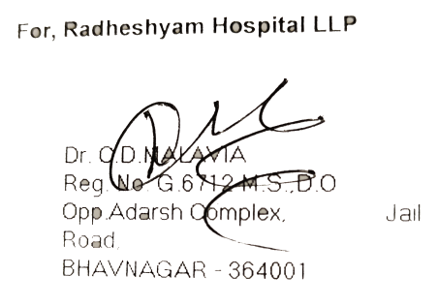

|  |
| --- |
| **MALAVIA EYE HOSPITAL**  (Unit: Radheshyam Hospital LLP)  Plot No: 1, Marine Society, Opp. Adarsh Complex, Jail Road, Bhavnagar- 364001. |